12-02-2021
PCI Hospital and Operator Reports:
Data Analysis Explanation

This document provides a summary of the data cleaning and analysis protocol used in generating the Hospital and Consultant Operator reports for the Clinical Outcomes Publication (COP) report. It should be read in conjunction with the document ‘PCI Data Import to NICOR Logic and Internal Validation rules’ available from the BCIS website.

The data in the NICOR servers must be an accurate representation of the PCI procedures performed:
1. All procedures must be present, with no missing procedures or duplicates
2. The fields in each record must be accurate
3. The fields in each record must be as complete as possible.

The dataset comprises both PCI procedures and interventional diagnostic procedures (IDPs), and the operator and hospital reports are based on PCI procedures ONLY. The details are below, but essentially these are defined as procedures where the number of lesions attempted is 1 or more.

There are a number of tools to help you validate your data and check for completeness that are described in below.

1. How the data are analysed

1. 1 Primary Data Subset
Year of data is determined according to the derived field ‘3.01 Year of Operation’ as provided in extracts from the NICOR Technical Team. Data from the three most recent financial years (1st April to 31st March) are identified and retained for the analysis.

Field ‘3.11 Number of Lesions Attempted’ is used to identify records for PCI procedures. The following logic is used to identify invalid records that are excluded from the analysed dataset. Records are excluded if field 3.11:
- Does not have a valid value of 1 or more (so excluding diagnostic only studies)
- Is blank or not a valid number
- Is less than ‘3.12 Number of chronic occlusions attempted’
- Is less than ‘3.13 Number of restenosis attempted’
- Is less than ‘3.14 Number of instent stenoses attempted’

Hospitals are identified on the basis of field ‘1.01 Hospital’, while individual operators are identified on the basis of field ‘5.31 Consultant Responsible for Procedure GMC Number’.

Logical checks are applied to life status fields to ensure outcome data are valid prior to analysis:
If ‘4.03 Status At Discharge’ includes the value "Alive", a missing value, or an illegal value, and ‘4.01 PCI Hospital Outcome’ includes the value "Death", ‘4.03 Status At Discharge’ is recoded as "Dead".

If ‘4.01 PCI Hospital Outcome’ does not include the value "Death", and ‘4.03 Status At Discharge’ includes the value "Dead", a value of "Death" is added to ‘4.01 PCI Hospital Outcome’.

Values in ‘4.01 PCI Hospital Outcome’ are relabelled as invalid if it includes only the values "No complications" or "Unlisted" but ‘5.21 Patient Status During Transfer to Theatre’ includes any of the following values-
- "External massage"
- "Haemodynamically unstable"
- "Haemodynamically stable"

If ‘4.01 PCI Hospital Outcome’ includes only the value "Unlisted", it is subsequently treated as indicating that "No complications" occurred.

If tracked 30 day post-procedural mortality is missing, but in-hospital mortality is reported for that record and occurred within 30 days of the procedure, then the missing 30 day mortality value is recoded as “Dead”.

On rare occasions, multiple copies of records for the same procedure are found to be duplicated and so stored twice or more in the database. Duplicate records are removed prior to analysis. Identification is done in two stages. Firstly, the derived ‘Artemis - Pseudonymised 1.01 Hospital Code + 1.02 Hospital Number’ field is examined in combination with field ‘3.01 Date/Time of Operation’ and records that have exact matches on these fields are identified for further examination. Where duplicate records are identified, the record that was most recently uploaded by the hospital is retained and the other record excluded. A follow-up test is also performed to identify any remaining duplicates again using ‘3.01 Date/Time of Operation’, but this time in combination with fields ‘1.01 Hospital’ and the derived field ‘Apollo - Pseudonymised 1.03 NHS Number’.

After the above cleaning is completed, the resultant data becomes the primary analysis subset for all subsequent work.

1. 2 Clinical Syndrome Analysis
The summary of clinical syndromes for each record is generated according the following criteria:

Stable: where field ‘2.02 Indication for Intervention’ includes any of the following values-
- "Stable - angina"
- "Stable - coronary anatomy / LV function"

ACS not STEMI: where field ‘2.02 Indication for Intervention’ has the value "ACS - UA, NSTEMI or convalescent STEMI".

Primary PCI: where field ‘2.02 Indication for Intervention’ includes any of the following values-
- "ACS - Primary PCI for STEMI (no lysis)"
- "ACS - Facilitated PCI for STEMI (lysis + PCI)"

Other: where field ‘2.02 Indication for Intervention’ includes any of the following values-
- "ACS - Rescue PCI for STEMI (failed lysis)"
- "ACS - PCI for reinfarction (no lysis)"
- "ACS - Rescue PCI for reinfarction (failed lysis)"
- "Staged procedure"
- "Hybrid procedure"
- "Acute or subacute PCI thrombosis"
- "Bail out following complication of diagnostic cardiac catheterisation"

Unknown: where field ‘2.02 Indication for Intervention’ has a missing value, an invalid value or any of the following values-
- "Unlisted"
- "Unknown"

Shock: where field ‘2.04 Cardiogenic Shock Pre-Procedure’ includes the value "Yes".

VentilatedPreOp: is identified where field ‘5.07 Ventilated PreOp’ includes the value "Yes".

1.3 Radial Access Rates
The number of cases where radial access was used as a percentage of all cases. If access was from both radial and femoral, then this is counted in the radial case totals. This is reported for the most recent year only.

1.4 Centre-Specific Delay to Treatment: Primary PCI Procedures
This measure covers delays to treatment by primary PCI for patients presenting with ST elevation MI. Data presented as percentage treated within 90 minutes of arrival at the PCI centre ‘door’. This includes inter-hospital transfers (but timing is still from PCI centre door). This is reported for the most recent year (not all 3 years) and is included in hospital reports only.

Basic Summary of Exclusions:
1. Symptom onset while already in hospital (excluded)
For those whose symptoms started after admission to a referring hospital, this is assessed by excluding patients whose admission route is recorded as ‘interhospital transfer’ and whose symptoms started AFTER admission to that first hospital. For those admitted directly to a PCI centre, those with admission route ‘already in PCI centre’ are excluded. This field can cause confusion. The admission route is the one that relates to the PCI – so if a patient is admitted to the PCI centre for a reason other than STEMI and then develops STEMI while in, admission route need to be recorded as ‘already in’
2. Pre-procedural cardiogenic shock (excluded)
3. Requirement for pre-procedural ventilation (excluded)

Full Explanation of Calculation:
A primary cut is created retaining only records where:
-at least one lesion is known to have been attempted
-the indication for intervention is "ACS - Primary PCI for STEMI (no lysis)"
(Note that this does not include facilitated PCI for STEMI. This may be subject to change in future analyses.)
-pre-procedural cardiogenic shock is not recorded
-pre-procedural ventilation is not recorded
-the time of first balloon is recorded and valid
-where both fields are recorded and valid, symptom onset is known to have occurred before the first balloon
-where both fields are recorded and valid, symptom onset is known to have occurred before discharge date
-where both fields are recorded and valid, the first balloon is known to have occurred before discharge date
-where both fields are recorded and valid, symptom onset is known to have occurred before the procedure time
-where both fields are recorded and valid, the first balloon and procedure time occurred within the same 24 hour window
-where both fields are recorded and valid, the procedure time occurred before or on the same day as the discharge date.

For the direct admission cut, the denominator is calculated using procedures where:
- the admission route is "Direct to cardiac centre (from the community)"
- the derived door time is known and valid
- the derived door time is before the recorded time of first balloon
Derived door time (DDT) is determined as follows:
If Door 1 and Door 2 are both unknown, DDT is likewise coded as unknown. DDT is based on the recorded Door 1 value where this value is known and either Door 2 has an identical value to that recorded for Door 1 or its value is not recorded. Where both Door 1 and Door 2 are known but are not identical, then DDT is coded as unknown. Finally, if Door 1 is not known but Door 2 is, then DDT is based on Door 2.
Door to balloon for the directly admitted patients is then calculated as the time between the derived door time and the time of the first balloon inflation. The numerator for each hospital is the number of procedures where this interval was less than 90 minutes.

For the inter-hospital transfer cut, the denominator is calculated using procedures where:
- the admission route is "Interhospital transfer"
- the symptom onset is recorded as having occurred before arrival at the first hospital and both times are validly recorded
- the arrival at the PCI hospital is recorded as having occurred before both the time of first balloon and all times are validly recorded
Door to balloon for the interhospital transferred patients is then calculated as the time between the date of arrival at the PCI hospital and the time of the first balloon inflation. The numerator for each hospital is the number of procedures where this interval was less than 90 minutes.

For each centre, the numerators for the direct admissions and interhospital transfers are summed. Likewise, the denominators are combined. The resulting values are used to determine the overall percentage of primary PCI procedures in each centre where the door to balloon time was under 90 minutes.

1.5 Centre-Specific Delays to Treatment: Patients Presenting with NSTEMI
This measure tries to capture the entire delay for a patient, from admission to the first hospital (of a series if that has occurred), to ultimate treatment by PCI. All patients treated for NSTEMI, unstable angina or convalescent STEMI are included. Data are presented as percentage treated within 72 hours of initial presentation. This is reported for the most recent year (not all three years) and is included in hospital reports only.

Data completeness assessment
Route of admission is required to analyse these data. Completeness of this field is provided. To assess delays to treatment for those admitted directly to a PCI centre, admission time is also needed (derived door time ‘DDT’ is used as defined below). To assess IHT delays, we need to be able to exclude patients who develop symptoms while already in the referring hospital (the analysis is only for patients developing symptoms while in the community). To identify these patients we need to know whether the NSTEMI symptoms occurred before or after admission to that centre – therefore symptom onset and admission to referring hospital are required. Data completeness for these fields is therefore also provided.

Basic Summary of Exclusions:
1. Symptom onset while already in hospital (same logic as used for the patients with STEMI)

Full Explanation of Calculation:
A primary cut is created retaining only records where:
-at least one lesion is known to have been attempted
-the indication for intervention is "ACS - UA, NSTEMI or convalescent STEMI"
-where both fields are recorded and valid, symptom onset is known to have occurred before the first balloon
-where both fields are recorded and valid, symptom onset is known to have occurred before discharge date
-where both fields are recorded and valid, the first balloon is known to have occurred before discharge date
-where both fields are recorded and valid, symptom onset is known to have occurred before the procedure time
-where both fields are recorded and valid, the first balloon and procedure time occurred within the same 24 hour window
-where both fields are recorded and valid, the procedure time occurred before or on the same day as the discharge date.

For the direct admission cut, the denominator is calculated using procedures where:
- the admission route is "Direct to cardiac centre (from the community)"
- the derived door time (DDT) is known and valid
- the procedure time is known and valid
- the DDT is known to have occurred before the procedure time
Door to balloon for the directly admitted patients is then calculated as the time between the derived door time and the time of the procedure. The numerator for each hospital is the number of procedures where this interval was less than 72 hours.

For the inter-hospital transfer cut, the denominator is calculated using procedures where:
- the admission route is "Interhospital transfer"
- symptom onset is known to have occurred before the arrival time at the first hospital and both fields are known and valid
- the procedure time is known and valid
- the arrival time at the first hospital occurred before the procedure time
Door to balloon for the directly admitted patients is then calculated as the time between the arrival time at the first hospital and the time of the procedure. The numerator for each hospital is the number of procedures where this interval was less than 72 hours.

For each centre, the numerators for the direct admissions and inter-hospital transfers are summed. Likewise, the denominators are combined. The resulting values are used to determine the overall percentage of nSTEMI procedures in each centre where the door to balloon time was under 72 hours.

1.6 Risk Adjusted Analyses: 30 day Mortality (ONS Tracked)
In assessing the results of risk adjusted outcome analysis, the focus should be on the fields that are used in the risk adjustment model.

30 day mortality is only reported for procedures undertaken in England and Wales as tracked mortality information is not yet available for Scotland and Northern Ireland.

The nine fields that will affect the risk calculation are:
- 1.06 Date of birth (used to derive age)
- 1.07 Sex
- 2.02 Indication for intervention
- 2.03 Procedure Urgency
- 2.04 Cardiogenic shock pre-procedure
- 2.13 Previous MI
- 2.16 Diabetic status
- 5.05 Medical History (which contains data about past history of CVA)
- 5.06 History of renal disease

Excluded procedures
Patients who are ventilated before the PCI procedure starts have been excluded from this analysis.

Multiple procedures
If a patient has had more than 1 PCI in the assessment period, the first in the sequence is analysed. Further procedures over the next 30 days are ignored, and clock starts again at day 31.

Missing data
If a risk factor is field is missing, or entered as ‘unknown’, it will be assigned to the lowest risk category. So for example if the field for cardiogenic shock is blank, it will be assumed that for that PCI shock was not present. Thus if shock was actually present, the model will predict a falsely low mortality for that procedure.

The mapping of all the fields is given below:
Field | Label | Data values that cause the model to assume risk factor not present
1.06 | Date of birth | NA
1.07 | Sex | Blank, 0 not known, 9 not specified
2.02 | Indication for intervention | Blank, 98 unlisted, 99 unknown
2.03 | Procedure Urgency | Blank, 9 unknown
2.04 | Cardiogenic shock pre-procedure | Blank
2.13 | Previous MI | Blank, 9 unknown
2.16 | Diabetic status | Blank, 9 unknown
5.05 | Medical History (containing PH CVA) | Any values that do not include 4 CVA
5.06 | History of renal disease | Blank, 9 unknown

Denominator issues
It is possible to inadvertently create duplicate procedures in NICOR, please check that the cases in NICOR are an accurate reflection of the actual procedures performed.

Risk factor graphics
In order to try to make it easier to identify potentially anomalous data, two sets of data summary plots are included at the back of the report.

‘Risk Factor Missingness’ shows the nine factors, with your data represented by the purple dot, against the background of all other operators / centres as grey dots.

‘Risk Factor Prevalence’ shows the prevalence of the factors used in the risk model. The indications and urgency (fields 2.02 and 2.03) have been grouped together as follows:
Group 1 | “stable – angina” OR  “stable – coronary/LV anatomy” OR  “staged procedure” OR  “hybrid procedure”
Group 2 | “ACS - UA, NSTEMI or convalescent STEMI” AND (NEITHER “emergency” NOR “salvage”)
Group 3 | “ACS - UA, NSTEMI or convalescent STEMI” AND (EITHER “emergency” OR “salvage”)
Group 4 | “ACS - Primary PCI for STEMI (no lysis)” OR  “ACS - Facilitated PCI for STEMI (lysis + PCI)” OR  “Acute or sub-acute PCI thrombosis” OR  “Bail out following acute complication of diagnostic cardiac catheterisation”
Group 5 | “ACS - Rescue PCI for STEMI (failed lysis)” OR  “ACS - PCI for re-infarction (no lysis)” OR  “ACS - Rescue PCI for re-infarction (failed lysis)”

2.0 How to Access your Data
You can look at the data held in NICOR by logging into the ‘NCAP’ section of the NICOR web site (the same section used to upload your data to NICOR). From there you can assess data completeness, use the analytical tools provided to interrogate the NICOR data directly, or you can retrieve your data as a csv file for local analysis. The NCAP web site gives access to your data.

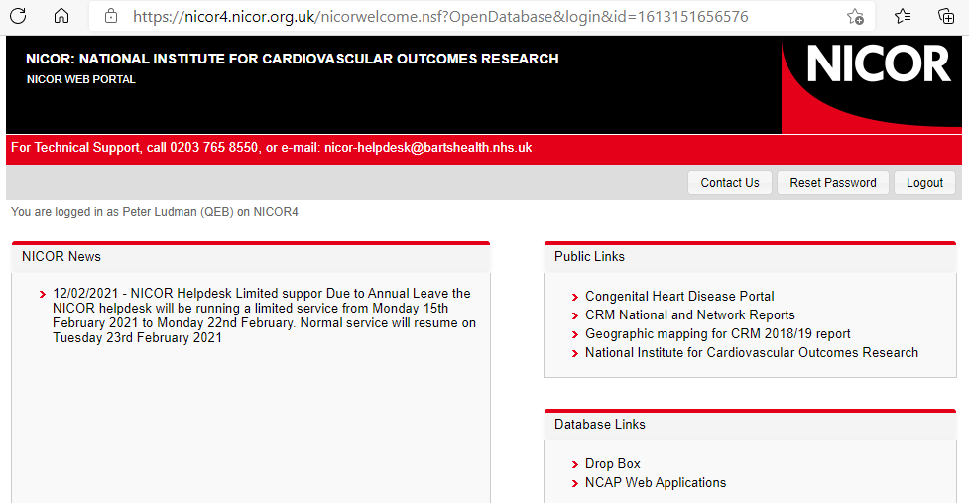

The menu provides several options:

2.1 Data completeness
This tool will assess every field in the dataset for level of completeness. This is presented by month, and columns are sortable by clicking the headers. The emptiest fields can thus be sorted to the top.

See user guide from link on web site

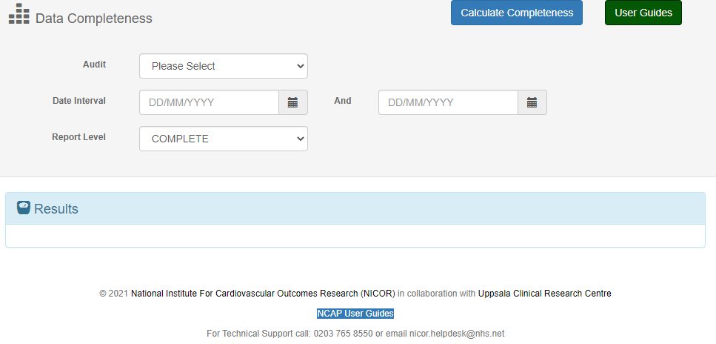

2.2 User reports
This gives access to pre-programmed data analyses that compare your centre with the National aggregated data. Again see user guides for details

2.3 Export your data for back from NICOR
This will provide a spreadsheet of your data between selectable date ranges, for local analysis for example with excel.

Best wishes

Peter Ludman
BCIS Audit Lead

