Guide to assessment of Clinical Outcomes Publication (COP) validation reports

Data for Procedures 2017-18 + 2018-19 + 2019-20

By Peter Ludman
12th February 2021

The analysis attached is of data you have uploaded to NICOR for PCI procedures in the time frame above. Once validated a final report will be created that will form part of the public report (centre / consultant operator).

It is very important that you check the accuracy of the data presented in this report. You can compare the presented analyses with analyses of your own in house data, or look at the data held in NICOR which is accessed via the ‘NCAP’ section of the NICOR web site (the same section used to upload your data to NICOR). From there you can either use the analytical tools provided to interrogate the NICOR data directly, or you can retrieve your data as a csv file for local analysis. Note that the data presented in the report below might differ slightly from your analyses of the ‘live’ data as the extract has been subject to a data cleaning process.

This summary help sheet should be read in conjunction with 2 full guides:
1. PCI Data Import to NICOR Logic and Internal Validation rules
2. PCI Data Analysis Details for Public Reports
(Available for download on BCIS web site)

Below is a brief overview of the structure of the 2017-18 + 2018-19 + 2019-20 reports:

1. Green or red headline – ‘data completeness for risk adjusted outcomes’:
Or
This refers to the breakdown given on page 4 of the report. The actual result of risk adjusted outcomes is not provided in this report as it relies on an ONS track that has not yet been completed.

2. Totals – Hospital reports show all consultants at that centre - e.g.:
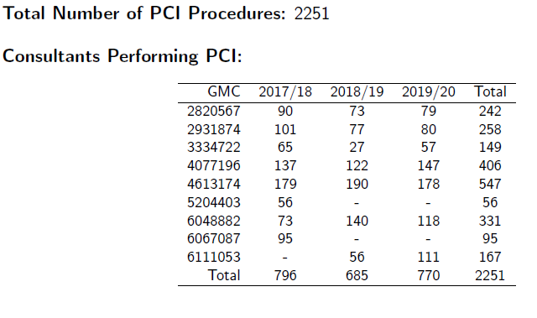

Check the total number of procedures at the top, and by each year (at the foot of the table) is what you expect. (Remember these are PCI procedures defined in the dataset as where number of lesions attempted >0).

Check there are no ‘unknown’ GMC numbers, as in example below:
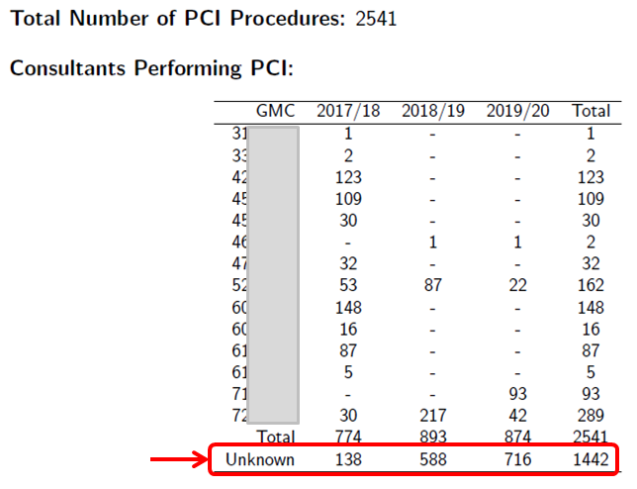

This occurs when a procedure does not have the ‘GMC number of responsible consultant’ completed with a valid value. The GMC number is a series of 7 digits, and for example we have found that some database software incorrectly adds the letter ‘C’ at the start. This would cause it to be rejected. Whoever performed that procedure is therefore unknown to NICOR and the procedure cannot be ascribed to any consultant, and so will not be counted as activity performed by that consultant in the consultant operator report. The error should have been apparent as it would have been reported in the import logs created after your data uploads.

If you receive a Consultant Operator report with lower procedure numbers than you expect – this may be the explanation. The quickest way to check is to look at the Hospital report that will have been sent to the audit/clinical lead at your hospital.

The Consultant Operator reports show a count of that operator’s procedures. This year we have included both a count of PCI procedures (defined as number of lesions attempted > 0) and also a count of Interventional Diagnostic Procedures (defined as number of lesions attempted = 0). There is also a split of PCI procedures at each centre over the last 3 years.

3. Go through the rest of the data cuts and analyses and make sure they fit with your understanding of your own data.

‘Numbers Split by clinical syndrome’
‘Radial access rate’

4. For hospital reports only:
For centres performing primary PCI:
‘Door to balloon’ times – both data completeness and % within 90min result

‘NSTEMI’ admission route %
‘NSTEMI’ data completeness
If completeness is sufficient then a result is provided:
‘NSTEMI’ % treated within 72 hours (split by admission routes).

If completeness is inadequate (any key field < 95%), then this message is provided:

5. Data completeness for risk adjustment – this is what was referred to in the opening statement of this report (‘1’ above). For example:
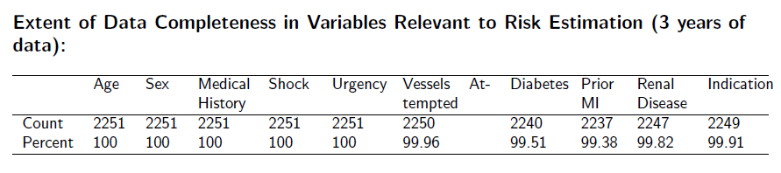

Any falling below 95% will trigger a red ‘inadequate’ statement in red at the top of this report.

6. Risk factor completeness
This series of plots shows where your unit sits relative to all others. Statistically you are likely to be in the middle of all the other grey dots. For example:

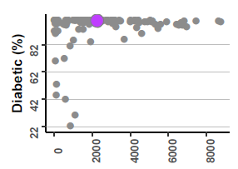

If however you are an obvious outlier – it is likely your data are incorrect:

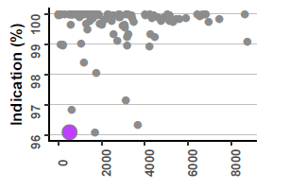
outlier

7. Risk factor prevalence plots

The same applies to these plots. They are designed to help spot any obvious data errors. This looks OK:
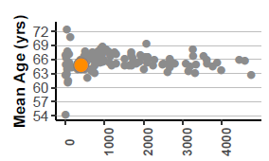

However the plot below suggests a data entry, or a database mapping error:
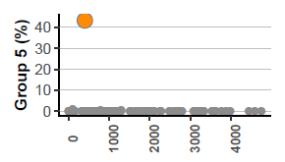
outlier

